Chapter 15, Problem 17.

Using Fig. 15.29, design a problem to help other students better understand the Laplace transform of a simple, non-periodic waveshape.
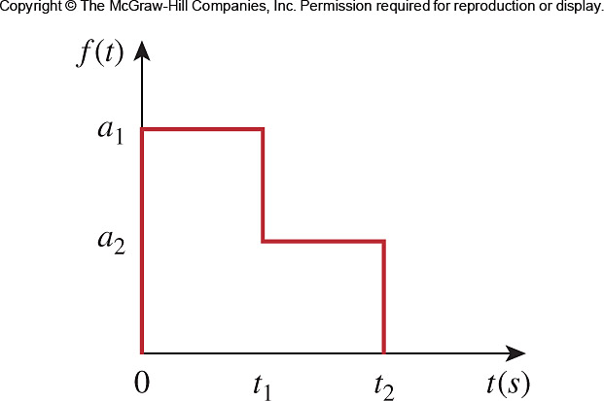

Figure 15.29
For Prob. 15.17.

